

**Informatics Institute of Technology**

**Department of Computing**

**(B.Eng) in Software Engineering**

**Module:**

**COSC0011C Web Design & Development**

**4**

**Module Leader: Ms. Aloka Fernando**

**Group Coursework Report**

Tutorial Group

:

SE/CS GROUP D

Coursework Group No:

Table of Contents

1. Introduction 2

2. Technical Discussion 3

3. Discussion of UI and application of UX principles 6

3.1 Information architecture 6

3.2 Colour balance/composition/graphics/consistency a. Design 12

3.3 Typography / consistency 14

3.4 Gestalt principles grouping 15

3.5 Accessibility (graphics/forms) 16

3.6 Error prevention and recovery 17

4 Janet 17

6 Conclusions 18

References 18

Appendices 18

https://www.w3schools.com/html/ 18

Appendix A: Code 18

Appendix B: Screenshots 56

Appendix C: Individual Statement 62

05

CCC

Student

IIT

ID

:

2018015

a

Student UoW ID

:

W1714852

Student First Name

:Chamal

Student Surname

:Perera

Table of Contents

1. Introduction 2

2. Technical Discussion 3

3. Discussion of UI and application of UX principles 6

3.1 Information architecture 6

3.2 Colour balance/composition/graphics/consistency a. Design 12

3.3 Typography / consistency 14

3.4 Gestalt principles grouping 15

3.5 Accessibility (graphics/forms) 16

3.6 Error prevention and recovery 17

4 Janet 17

6 Conclusions 18

References 18

Appendices 18

https://www.w3schools.com/html/ 18

Appendix A: Code 18

Appendix B: Screenshots 56

Appendix C: Individual Statement 62

# 1. Introduction

Student 01: Toran Mayantha- Presentation Page, Product Page, Font Size Change

Student 02: Chamal Lakpriya- Main Page, Feedback Form, External CSS

Student 03- Sandeepa Sewandi - MCQ Quiz, Student Details

Student 04- Dulitha Iddawala- Diagrams, Images Page

|  |  |  |  |  |
| --- | --- | --- | --- | --- |
| **Task** | **Student 1** | **Student 2** | **Student 3** | **Student 4** |
| 1 - Presentation Page | * |  |  |  |
| 2 - Main Page |  | * |  |  |
| 3 - Font Size Change | * |  |  |  |
| 4 - Comments Form |  | * |  |  |
| 5 - Buy products | * |  |  |  |
| 6 - Diagrams |  |  |  | * |
| 7 - Quiz |  |  | * |  |
| 8 - View images |  |  |  | * |
| 9 - Student details |  |  | * |  |
| 10a - External CSS (created) |  | * |  |  |
| 10b - External CSS (10a reused) | * | * | * | * |
| 11 - CV | * | * | * | * |
| 12 - Anchors | * | * | * | * |
| 13 - Logo/Page Editor | * | * | * | * |
| 14 - Info. Page / design issues | * | * | * | * |
| 15 - Additional Interactivity | * | * | * | * |

Our Website is related to music instrument under the Music topic .I’ve done the Homepage, Feedback page and Basic Styling in Website.

.

# 

# 2. Technical Discussion

Subject & Style

The topic which we selected for our website is Music. Relating to music this website is to sell various kind of music Guitars. As it is a well known subject all over the world after discussing and concerning about many facts finally we end up with this subject with the approval of all the team members.

As music is a calm subject light colors and smooth music is used throughout the website for the betterment of the viewers of the website.

Student Details Page

As the student 02 I was asked to create a home page. That is to create beautiful home page for the website and make is so colorful.

Difficulties Faced

1. The first difficulty was to come up with an idea to do this task.

2. was Unable to make the home page background video

3. Unable to make the navigation bar

4. footer not perfectly fit for the website.

How they were solved

1. After searching and watching many tutorials i thought of using a hover effect, something which I haven't used before to complete this task. Because it was new to me I had to put an effort to reach the goal. I went through many tutorials and finally got how to do it.

2. Though it was a simple task it took me sometime to realize how to make the shape round. First i tried several several codes but it does not worked. I even tried to replace the image directly with a round shaped one instead of using CSS. Somehow at last with the help of a team member i managed to solve this problem. I got to know that it’s simply the border radius.

3, 4. I wanted to reduce the visibility of the image when the mouse is moved on the image and to display the text. So I had to reduce the opacity of the image. Even though the visibility got reduced it also effected on the text too, so the text was not clear. So finally I got another low contrast image and replaced it on top of the current picture, so the visibility of the image got reduced and the text was clearly displayed

Home page

I was asked to create a home page related to the topic with a nev bar and insert the bideo to the background.

Difficulties Faced

1. Creating the navigation bar

2. Creating the footer

3. insert the video to the home page

How they were solved

1. Creating the navigations bar was the biggest challenge for me. I went through so many tutorials and codes to find out how to create a nev bar with the hover effect. After studying them hard and after understanding the code I managed to create a nav bar with the hover effect. Once the page is loaded nav bar will appear and work with hover effect.

2. It was a problem for me to how to put the a video to the background. What i did was i create a video tag in html code and link the video to that tag. And after that I was put some CSS for that tag.

3. I wanted to display the footer at bottom of the page with the about us details and social media links.so what I did was I created two separate div tags inside of the footer tag and I divided footer to two part.after that I put some CSS and footer details for those tags.

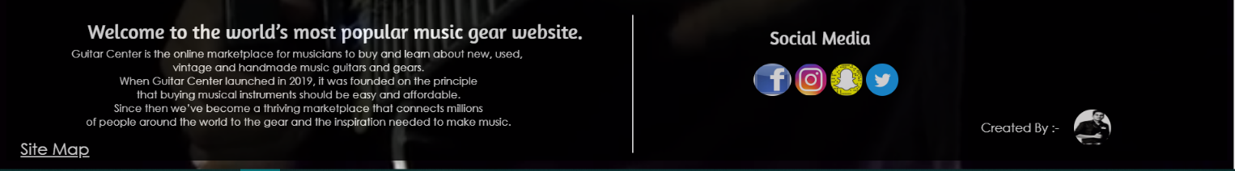



* Comments Form

Difficulties Faced

1. Creating the comment section

2. Creating the pop up massage

How they were solved

1./2. First I went through so many tutorials and website for the get proper idea about comment section and I did so many java script tutorial for gain some idea about comment section. After that the biggest problem was creating pop up massage. After got some idea about the java script from tutorials I just tried few time with some simple java script task.

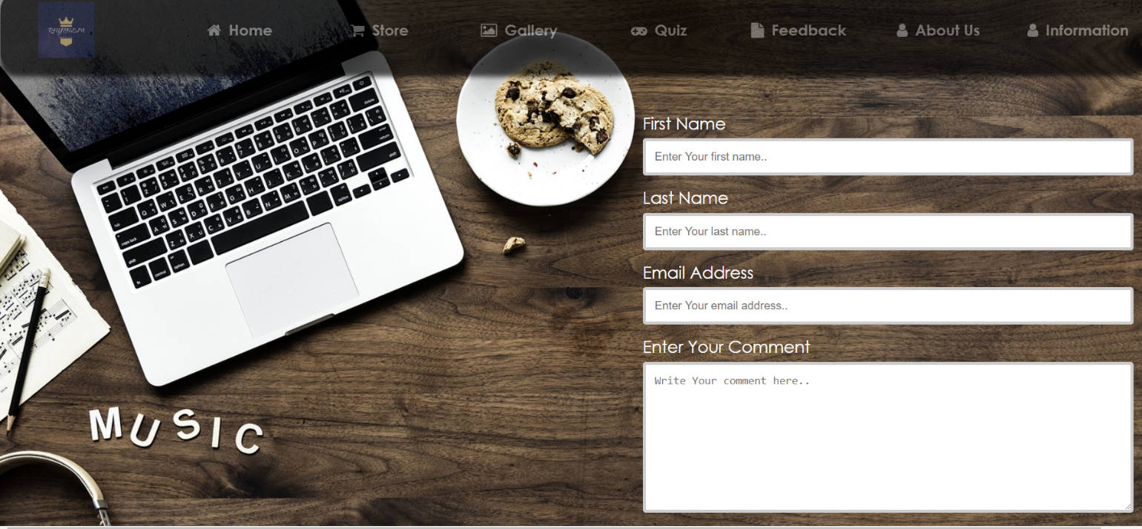

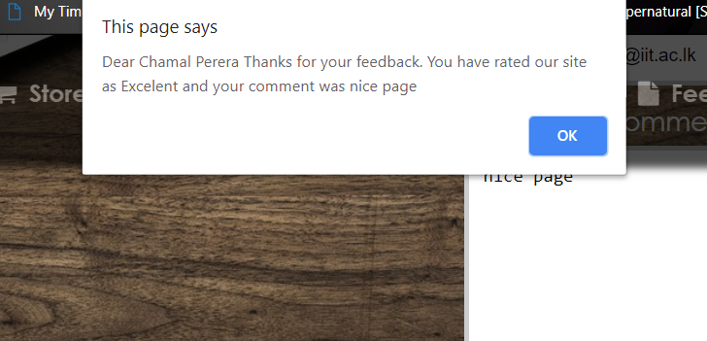

# 3. Discussion of UI and application of UX principles

## 3.1 Information architecture

1. Design

When I create the home page and comment page, I used simple and easy structure to the design.

When I apply CSS to the website, I conserved to apply light colors, simple font style and easy structure to the website. I used floating method to the web pages and it would be easy for the customer who prefer this website.

How did you implement the web site navigation system?

Html code:

<!-- Here starts the nav-->

<div class="nav">

<ul>

<!-- Here starts the logo and big1-->

<a class="logo" href="Home Page.html"><img src="Images/logo.png" width="75" height="75"></a>

<li><a class="big1" href="Home Page.html"><i class="fa fa-home"></i>Home</a></li>

<li><a class="big1" href="store.html"><i class="fa fa-shopping-cart"></i>Store</a></li>

<li><a class="big1" href="index.html"><i class="fa fa-photo"></i>Gallery</a></li>

<li><a class="big1" href="Quiz.html"><i class="fa fa-gamepad"></i>Quiz</a></li>

<li><a class="big1" href="Feedback.html"><i class="fa fa-file"></i>Feedback</a></li>

<li><a class="big1" href="about.html"><i class="fa fa-user"></i>About Us</a></li>

<li><a class="big1" href="Information.html"><i class="fa fa-user"></i>Information</a></li>

</ul>

</div>

CSS code:

a.big1:hover,

a.big1:active {

font-size: 150%;

}

/** make naviagation bar */

.nav {

width: 100%;

background: black;

height: 100px;

margin: 0px;

opacity: 0.7;

box-shadow: 0px 10px 10px #000000;

z-index: 1;

/** this helps to place navigation bar over the vedio. */

top: 0;

/** this helps to place on the top of the website. */

position: fixed;

border-radius: 20px;

}

/** change the inside of navigation bar */

ul {

list-style: none;

padding: 0;

margin: 0;

position: relative;

float: right;

}

/** make naviagation bar */

li {

margin-top: 25px;

position: relative;

float: left;

}

/** change the positions and sizes of the logo */

.logo {

width: 165px;

padding: 10px;

float: left;

position: relative;

margin-left: 10px;

margin-top: 0px;

}

/** decorate the inside things of navigation bar */

ul li a {

width: 165px;

color: gray;

display: block;

text-decoration: none;

font-size: 20px;

text-align: center;

padding: 10px;

border-radius: 20px;

font-family: Century Gothic;

font-weight: bold;

}

/** when user move the cursive to inside thing of navigaton bar it willbe changed the colour */

ul li a:hover {

background: #02547a;

}

/** change the position of icons inside the navigation bar */

ul li a i {

margin-right: 10px;

}

/** show the dropdown navigation bar over the images and other thing */

ul li ul li {

float: none;

z-index: 2;

}

/** custamize the colors and other thing of dropdown navigation bar */

ul li ul {

background-color: black;

display: none;

border-radius: 20px;

}

/** user move the cursive to main navigaton bar and then show the drpdown navigation bar */

ul li:hover ul {

display: block;

}

We didn’t used same style for the each and every pages. But as a website we put same nev bar and footer for the every page. Couse when user prefer the website, he/she can easily access to the website.

1. Code to achieve good Information architecture

For example the template created for your individual pages and for navigation.

## 3.2 Colour balance/composition/graphics/consistency a. Design

I’ve used a dark theme there I’ve used the colors gray and black and white in the fonts. In addition I’ve used the logo in dark. I’ve made the logo transparent and put in the navigation bar. I have used the full HD photos of 1080p resolution in the background so the visitors are able to see the website more clearly. I’ve used videos to make the home page background more attractive. I’ve imported icons from fontawesome.com for the navigation bar. Moreover I’ve used social media logos in the footer.

1. Code to achieve good colour balance & ensure consistency

I’ve used colors grey black and white to background and fonts using CSS. I’ve used the hover effect in blue for the navigation bar. Footer is transparent and black while the letters are white in color.

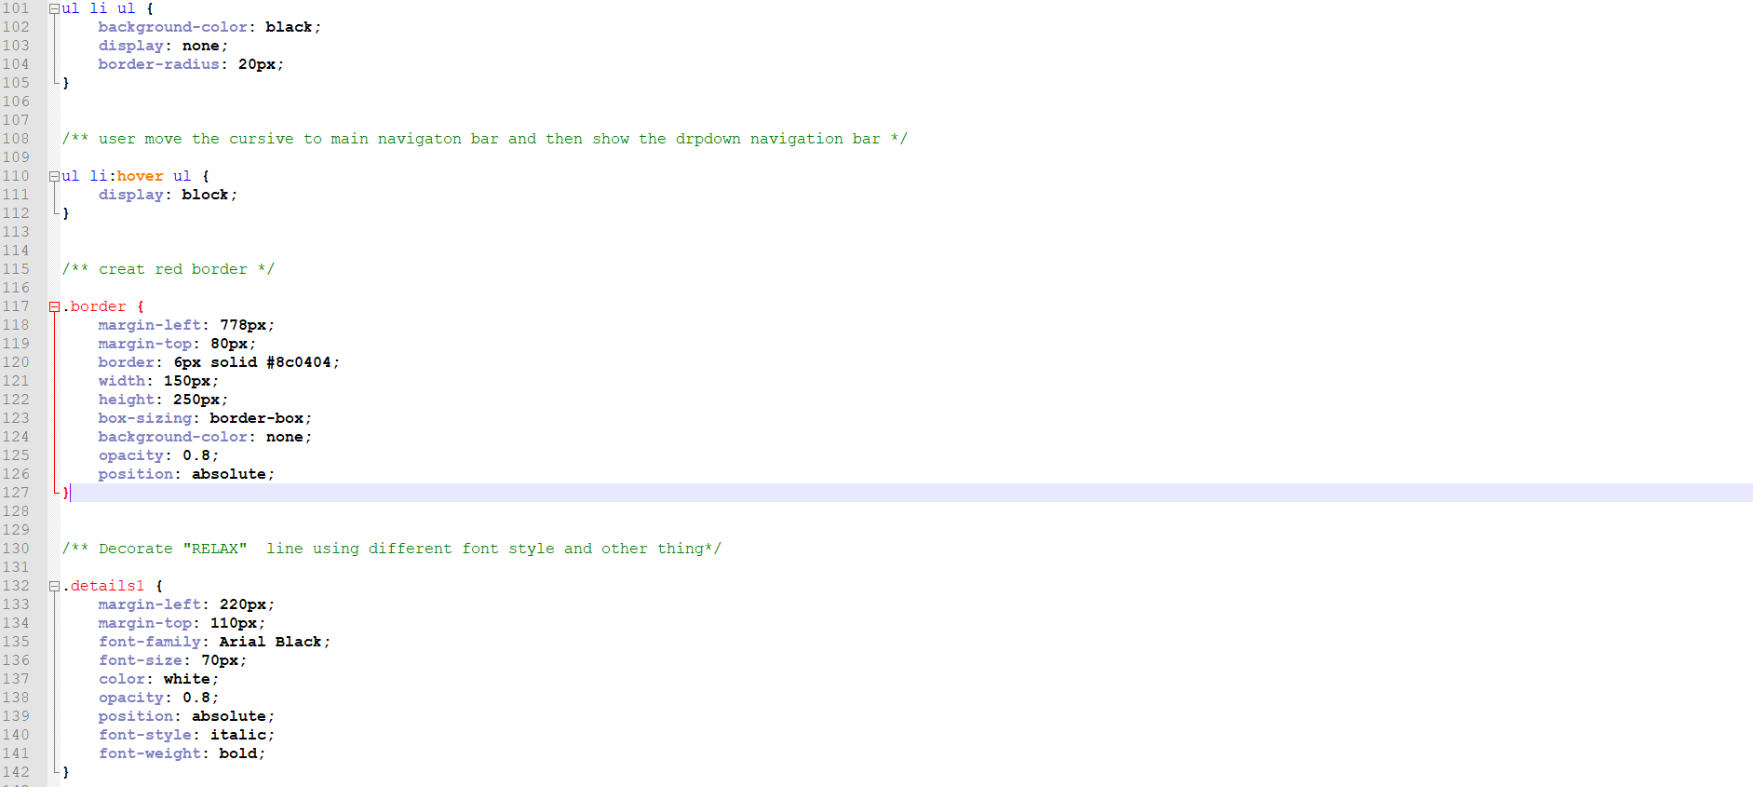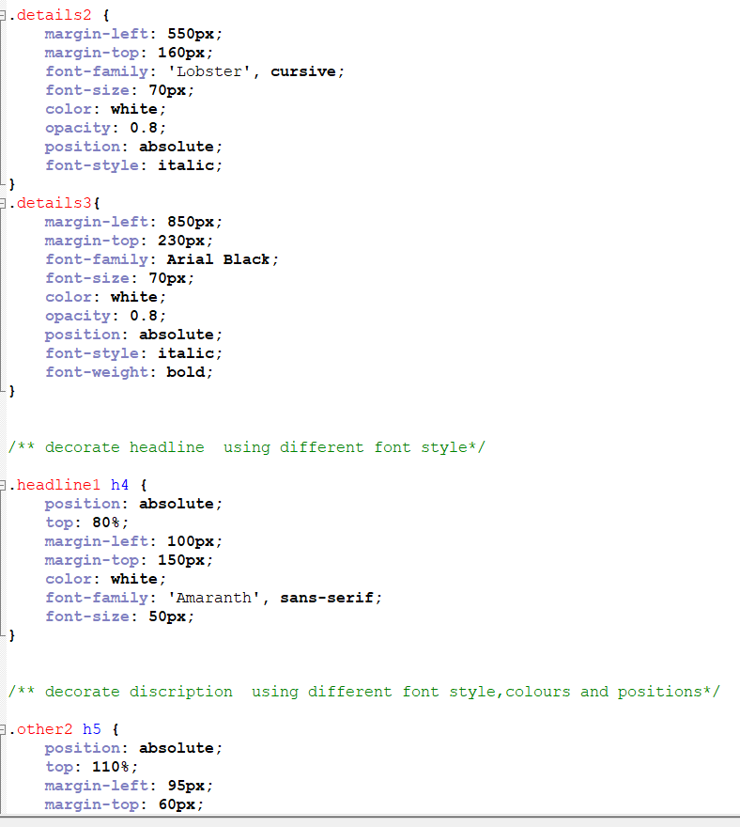

## 3.3 Typography / consistency

1. Design

As fonts I’ve Century Gothic in navigation bar and 'Amaranth', sans-serif in footer. I’ve increased and used bigger font sizes in background video in the home page and in the feedback page. In addition I’ve used fonts in medium size in footer, home page and feedback page and when comparing the rest have a smaller font sizes. I’ve bolded the letters in home page and in the feedback page. I’ve used the italic effect in some words in the that displays over the video of the homepage background.

1. Code to achieve good typography / consistency

I’ve changed the font colors using CSS, as colors I’ve used grey and white in the fonts.

## 3.4 Gestalt principles grouping

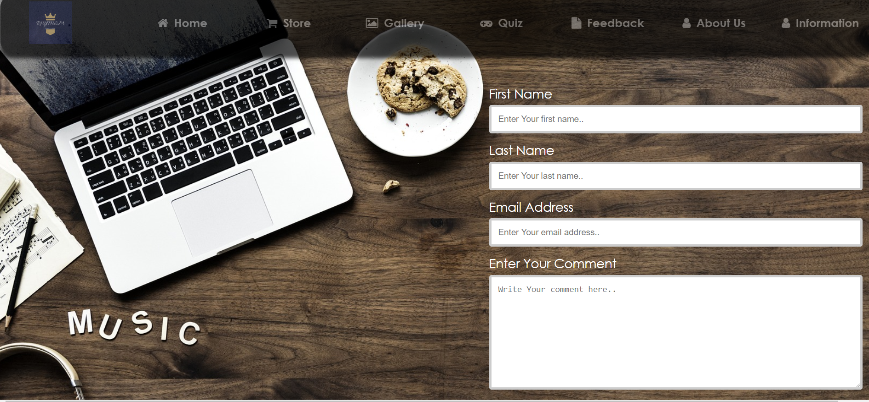

Here in the feedback page, I’ve mainly divided the page into two parts as shown above. I’ve aligned the feedback form to the right and inside the form texts like “first name”, “last name”, “email address” and “enter your comment” comes before the text boxes and all aligned to the left. So the visitor gets the clear idea that feedback form is separated and the visitors feedback is important while it’s given high priority.

## Accessibility (graphics/forms)

1. Graphical elements - Design/Code

I’ve imported icons from fontawesome.com in the navigation bar so the user can easily get the idea about where it navigates

Html code:

<div class="nav">

<ul>

<a class="logo" href="Home Page.html"><img src="Images/logo.png" width="75" height="75"></a>

<li><a class="big1" href="Home Page.html"><i class="fa fa-home"></i>Home</a></li>

<li><a class="big1" href="store.html"><i class="fa fa-shopping-cart"></i>Store</a></li>

<li><a class="big1" href="index.html"+><i class="fa fa-photo"></i>Gallery</a></li>

<li><a class="big1" href="Quiz.html"><i class="fa fa-gamepad"></i>Quiz</a></li>

<li><a class="big1" href="Feedback.html"><i class="fa fa-file"></i>Feedback</a></li>

<li><a class="big1" href="about.html"><i class="fa fa-user"></i>About Us</a></li>

<li><a class="big1" href="Information.html"><i class="fa fa-user"></i>Information</a></li>

</ul>

</div>.

I



1. Form completion - Design/Code

I’ve used anchor tags in the navigation bar icons so that has increased the accessibility to the user.

## Error prevention and recovery

1. Design

I’ve used instructions when user enters a comment to the feedback form.

1. Code to address error prevention and recovery

# 4 Janet

* Creation or transmission, or causing the transmission, of any hostile, disgusting or foul pictures, information or other material, or any information fit for being settled into profane or obscene pictures or material.
  + The Images which I utilized for my work are simply the pictures and nothing is duplicated from sites
  + Indeed, even the logo of the site was made utilizing Photoshop
* Creation or transmission of material with the end goal this encroaches the copyright of another person.
* Deliberate unauthorized access to networked facilities or services.
  + Haven’t use any links or re directs to external websites

# Conclusions

This course work helped me to achieve a good knowledge about css and advance html. As for the work load this is a group course work. So team work is important. Good coordination inside a team will increase efficiency and quality of the project greatly. So I learnt how to collect ideas as a group and make it those ideas into a well build professional looking web site.

As for the start my css and html skills were very poor. After I started this course work little by little I gained knowledge in all the aspects that covers the module.

From this course work I learnt,

* How to work in a team.
* How to do advance html.
* How to increase the quality in work.
* How to have a good finish.

So after all I think I have done my part perfectly. There for this course work is a 100% success.

# References

Provide references to resources you may have used

# Appendices

## <https://www.w3schools.com/html/>

<https://www.tutorialspoint.com/html/>

<https://www.youtube.com/watch?v=v4oN4DuR7YU>

## Appendix A: Code

**Filename: Home page**

**Code: Home page.html**

<!DOCTYPE html>

<html>

<head>

<title>HomePage</title>

<link rel="stylesheet" type="text/css" href="CSS\navigationbar.css">

<link rel="stylesheet" href="https://cdnjs.cloudflare.com/ajax/libs/font-awesome/4.7.0/css/font-awesome.min.css">

<!-- Here is the naviagtion bars icons link-->

<link href="https://fonts.googleapis.com/css?family=Lobster" rel="stylesheet">

<link href="https://fonts.googleapis.com/css?family=Amaranth|Changa|Economica" rel="stylesheet">

<meta charset="UTF-8">

<!-- Here is the internel css. it change the size and the positions of the vedio-->

<style>

.myVideo {

position: fixed;

right: 0;

bottom: 0;

min-width: 100%;

min-height: 100%;

z-index: -1;

background-size: cover;

}

</style>

</head>

<body>

<!-- Here starts the my vedio-->

<video autoplay muted loop class="myVideo">

<!-- vedio is muted and run as a loop-->

<source src="Video\video.mp4" type="video/mp4">

</video>

<!-- Here starts the nav-->

<div class="nav">

<ul>

<!-- Here starts the logo and big1-->

<a class="logo" href="Home Page.html"><img src="Images/logo.png" width="75" height="75"></a>

<li><a class="big1" href="Home Page.html"><i class="fa fa-home"></i>Home</a></li>

<li><a class="big1" href="store.html"><i class="fa fa-shopping-cart"></i>Store</a></li>

<li><a class="big1" href="index.html"><i class="fa fa-photo"></i>Gallery</a></li>

<li><a class="big1" href="Quiz.html"><i class="fa fa-gamepad"></i>Quiz</a></li>

<li><a class="big1" href="Feedback.html"><i class="fa fa-file"></i>Feedback</a></li>

<li><a class="big1" href="about.html"><i class="fa fa-user"></i>About Us</a></li>

<li><a class="big1" href="Information.html"><i class="fa fa-user"></i>Information</a></li>

</ul>

</div>

<br><br><br><br><br><br><br><br><br><br>

<!-- Here starts the headline-->

<div class="headline">

<div class="border"></div>

<div class="details1">"RELAX.</div>

<div class="details2">BE YOURSELF.</div>

<div class="details3">PLAY A LOT."</div>

</div>

<br><br><br><br><br><br><br><br><br><br><br><br><br><br><br><br><br><br><br><br><br><br><br><br><br>

<!-- Here starts the discription of the website-->

<div class="headline1">

<h4>DISCOVER THE MOST POPULAR GUITARS IN ONE PLACE.</h4>

</div>

<div class="Hl"></div>

<!-- Here starts the discription of the website-->

<div class="other2">

<h5>Guitar center gives you instant access to buy most popular guitars <br>from cheapest prizes to highest prices.<br></h5>

</div>

<br><br><br><br><br><br><br><br><br><br><br><br><br><br><br><br><br><br><br><br><br><br><br><br><br>

<!-- Here starts the footer of website-->

<div class="footer">

<div class="aboutsitetitle">Welcome to the world’s most popular music gear website.</div>

<div class="discription">

Guitar Center is the online marketplace for musicians to buy and learn about new, used, <br>vintage and handmade music guitars and gears.<br>

When Guitar Center launched in 2019, it was founded on the principle<br> that buying musical instruments should be easy and affordable.<br>

Since then we’ve become a thriving marketplace that connects millions<br> of people around the world to the gear and the inspiration needed to make music.

<p><a href="Sitemap.html">Site Map</a></p>

</div>

<!-- Here starts the social media-->

<div class="socialmedia">

<a class="social">Social Media</a>

<a href="https://en-gb.facebook.com/login/"><img src="Images/fb.jpg" width="46" height="40"></a><!-- Here the facebook link and other things-->

<a href="https://www.instagram.com/accounts/login/"><img src="Images/insta.png" width="40" height="40"></a><!-- Here the facebook link and other things-->

<a href="https://accounts.snapchat.com/accounts/login?continue=https%3A%2F%2Faccounts.snapchat.com%2Faccounts%2Fwelcome"><img src="Images/snapchat.jpg" width="40" height="40"></a><!-- Here the facebook link and other things-->

<a href="https://twitter.com/login?lang=en"><img src="Images/twiter.jpg" width="40" height="40"></a><!-- Here the facebook link and other things-->

<div class="vl"></div>

<!--this one for make a vertical line-->

</div>

<div class="owner">Created By :-</div>

<a href="Chamal Perera.html" class="ownerphoto"><img src="Images/my.jpg" width="45" height="45"></a>

</div>

</body>

</html>

**Filename: Home page**

**Code: Home page.css**

/** when user move the cursive to inside thing of navigation bar it will be increased the font size of elements */

a.big1:hover,

a.big1:active {

font-size: 150%;

}

/** make navigation bar */

.nav {

width: 100%;

background: black;

height: 100px;

margin: 0px;

opacity: 0.7;

box-shadow: 0px 10px 10px #000000;

z-index: 1;

/** this helps to place navigation bar over the vedio. */

top: 0;

/** this helps to place on the top of the website. */

position: fixed;

border-radius: 20px;

}

/** change the inside of navigation bar */

ul {

list-style: none;

padding: 0;

margin: 0;

position: relative;

float: right;

}

/** make navigation bar */

li {

margin-top: 25px;

position: relative;

float: left;

}

/** change the positions and sizes of the logo */

.logo {

width: 165px;

padding: 10px;

float: left;

position: relative;

margin-left: 10px;

margin-top: 0px;

}

/** decorate the inside things of navigation bar */

ul li a {

width: 165px;

color: gray;

display: block;

text-decoration: none;

font-size: 20px;

text-align: center;

padding: 10px;

border-radius: 20px;

font-family: Century Gothic;

font-weight: bold;

}

/** when user move the cursive to inside thing of navigation bar it will be changed the colour */

ul li a:hover {

background: #02547a;

}

/** change the position of icons inside the navigation bar */

ul li a i {

margin-right: 10px;

}

/** show the dropdown navigation bar over the images and other thing */

ul li ul li {

float: none;

z-index: 2;

}

/** custamize the colors and other thing of dropdown navigation bar */

ul li ul {

background-color: black;

display: none;

border-radius: 20px;

}

/** user move the cursive to main navigaton bar and then show the drpdown navigation bar */

ul li:hover ul {

display: block;

}

/** creat red border */

.border {

margin-left: 778px;

margin-top: 80px;

border: 6px solid #8c0404;

width: 150px;

height: 250px;

box-sizing: border-box;

background-color: none;

opacity: 0.8;

position: absolute;

}

/** Decorate "RELAX" line using different font style and other thing*/

.details1 {

margin-left: 220px;

margin-top: 110px;

font-family: Arial Black;

font-size: 70px;

color: white;

opacity: 0.8;

position: absolute;

font-style: italic;

font-weight: bold;

}

/** decorate "BE YOURSELF" line using different font style*/

.details2 {

margin-left: 550px;

margin-top: 160px;

font-family: 'Lobster', cursive;

font-size: 70px;

color: white;

opacity: 0.8;

position: absolute;

font-style: italic;

}

.details3{

margin-left: 850px;

margin-top: 230px;

font-family: Arial Black;

font-size: 70px;

color: white;

opacity: 0.8;

position: absolute;

font-style: italic;

font-weight: bold;

}

/** decorate headline using different font style*/

.headline1 h4 {

position: absolute;

top: 80%;

margin-left: 100px;

margin-top: 150px;

color: white;

font-family: 'Amaranth', sans-serif;

font-size: 50px;

}

/** decorate discription using different font style,colours and positions*/

.other2 h5 {

position: absolute;

top: 110%;

margin-left: 95px;

margin-top: 60px;

color: white;

font-family: Century Gothic;

font-size: 22px;

}

/** make the size and position horizontal line between other1 and other2 lines*/

.Hl {

border-top: 4px solid white;

width: 370px;

position: absolute;

margin-left: 500px;

margin-top: 75px;

}

/** make the footer */

.footer {

position: relative;

margin-top: auto;

left: 0;

bottom: 0;

width: 100%;

height: 200px;

background-color: black;

color: white;

text-align: center;

opacity: 0.8;

}

/**decorate and change the position of vertical line inside the footer*/

.vl {

border-left: 2px solid white;

height: 170px;

position: absolute;

margin-left: -150px;

margin-top: -104px;

z-index: 0;

}

/**decorate the title of about the site*/

.aboutsitetitle {

z-index: 2;

margin-top: 25px;

margin-left: 100px;

position: absolute;

font-family: 'Amaranth', sans-serif;

font-size: 25px;

}

/** decorate the information of the site*/

.discription,.discription p a {

z-index: 2;

margin-top: 60px;

margin-left: 80px;

position: absolute;

font-family: Century Gothic;

font-size: 13px;

}

.discription p a{

margin-left:-600px;

position:relative;

color: white;

font-family: Century Gothic;

font-size:20px;

}

.social {

z-index: 1;

margin-top: -46px;

margin-left: 20px;

position: absolute;

font-family: 'Amaranth', sans-serif;

font-size: 23px;

}

/** social media icons*/

.socialmedia {

position: absolute;

margin-top: 80px;

margin-left: 920px;

z-index: 1;

}

/** creater photo*/

.ownerphoto {

margin-top: 137px;

margin-left: 563px;

position: absolute;

font-family: Century Gothic;

font-size: 10px;

}

.owner {

margin-top: 150px;

margin-left: 1200px;

font-family: Century Gothic;

font-size: 15px;

position: absolute;

}

.ownerphoto img,

.socialmedia img {

/**change the border radius of photo*/

border-radius: 50%;

}

/**About us CSS**/

.aboutus{

margin-top:-70px;

margin-left: 600px;

position: absolute;

color: gray;

font-size: 50px;

font-family: 'Amaranth', sans-serif;

font-style: italic;

}

.paragraph{

margin-top: 350px;

margin-left: 300px;

font-family: 'Amaranth', sans-serif;

font-size: 30px;

margin-right: 350px;

color: white;

}

aboutusborder {

margin-left: 290px;

margin-top: 1500px;

position: relative;

border: 5px solid black;

width: 1200px;

height: 1000px;

box-sizing: border-box;

background-color: grey;

border-radius: 20px;

}

/********about us footer**********/

.footer1 {

position: relative;

margin-top: auto;

left: 0;

bottom: 0;

width: 100%;

height: 200px;

background-color: black;

color: white;

text-align: center;

opacity: 0.8;

}

/**index footer**/

.footer2 {

position: relative;

margin-top: 550px;

left: 0;

bottom: 0;

width: 100%;

height: 200px;

background-color: black;

color: white;

text-align: center;

opacity: 0.8;

}

**Filename: Feedback form**

**Code: Feedback.html**

<!DOCTYPE html>

<html>

<head>

<title>Feedback</title>

<link rel="stylesheet" type="text/css" href="CSS\feedback.css">

<link rel="stylesheet" type="text/css" href="CSS\navigationbar.css">

<link rel="stylesheet" href="https://cdnjs.cloudflare.com/ajax/libs/font-awesome/4.7.0/css/font-awesome.min.css">

<link href="https://fonts.googleapis.com/css?family=Amaranth|Changa|Economica" rel="stylesheet">

<meta charset="UTF-8">

<style>

body {

background:url('Images\\feedback.jpg');

background-size: cover;

}

</style>

<script>

function formValidations() {

var one = document.forms["feedback"]["firstname"].value; // if user doesnt input a value to first name then after submit this one gives the alert

if (one == "") {

alert("Please enter the first name and complete the form before submit");

return false;//Stops Executing the function.

}

var two = document.forms["feedback"]["lastname"].value; // if user doesnt input a value to first name then after submit this one gives the alert

if (two == "") {

alert("Please enter the last name and complete the form before submit");

return false;//Stops Executing the function.

}

if ( ( feedback.rating[0].checked == false ) && ( feedback.rating[1].checked == false ) && ( feedback.rating[2].checked == false ) && (feedback.rating[3].checked == false)){ //check the rating radio buttons one by one.

alert ( "Please rate the site before submit" ); // if user doesnt rate this one gives the alert

return false;//Stops Executing the function.

}

var firstName=document.feedback.firstname.value; //first name value stored in a variable

var lastName=document.feedback.lastname.value; //last name value stored in a variable

var text=document.feedback.Comment.value; //user comments stored in a variable

var rated;

if(feedback.rating[0].checked == true){ //check whether user rate is bad

rated="Bad";

}

else if(feedback.rating[1].checked == true){ //check whether user rate is not bad

rated="Not bad";

}

else if(feedback.rating[2].checked == true){ //check whether user rate is good

rated="Good";

}

else{ //check whether user rate is excelent

rated="Excelent";

}

if (text == ""){ //check whether user input a comment and if user doesnt input a comment then this statement willbe correct and display this

alert("Dear "+firstName+" "+lastName+" Thanks for your feedback. You have rated our site as "+rated+".");

}

else{ //check whether user input a comment and if user inputs a comment then this statement willbe correct and display this

alert("Dear "+firstName+" "+lastName+" Thanks for your feedback. You have rated our site as " +rated+ " and your comment was "+text);

}

}

</script>

</head>

<body>

<div class="nav">

<ul>

<a class="logo" href="Home Page.html"><img src="Images/logo.png" width="75" height="75"></a>

<li><a class="big1" href="Home Page.html"><i class="fa fa-home"></i>Home</a></li>

<li><a class="big1" href="store.html"><i class="fa fa-shopping-cart"></i>Store</a></li>

<li><a class="big1" href="index.html"+><i class="fa fa-photo"></i>Gallery</a></li>

<li><a class="big1" href="Quiz.html"><i class="fa fa-gamepad"></i>Quiz</a></li>

<li><a class="big1" href="Feedback.html"><i class="fa fa-file"></i>Feedback</a></li>

<li><a class="big1" href="about.html"><i class="fa fa-user"></i>About Us</a></li>

<li><a class="big1" href="Information.html"><i class="fa fa-user"></i>Information</a></li>

</ul>

</div>

<div class="interface">

<!--Here the form-->

<form name="feedback" autocomplete="off">

<!--erase the saved data-->

<label for="fname">First Name</label> <!-- Here the heading first name-->

<input type="text" name="firstname" placeholder="Enter Your first name.." >

<label for="lname">Last Name</label> <!-- Here the heading last name-->

<input type="text" name="lastname" placeholder="Enter Your last name..">

<label for="lname">Email Address</label> <!-- Here the heading email address-->

<input type="text" name="Email" placeholder="Enter Your email address..">

<label for="comment">Enter Your Comment</label> <!-- Here the heading enter your comment-->

<textarea name="Comment" placeholder="Write Your comment here.." style="height:200px"></textarea>

<div>

<label for="rate"><b>Rate our site</b></label>

<br><br>

<div class="rating">

<!-- Here the ratings-->

<input type="radio" name="rating"><b>Bad</b>

<input type="radio" name="rating"><b>Not Bad</b>

<input type="radio" name="rating"><b>Good</b>

<input type="radio" name="rating"><b>Excelent</b>

</div>

</div>

<p>

<input type="submit" name="Submit" onClick="formValidations()"> <!-- Here the submit button and when click the button js will work-->

</p>

</form>

</div>

<br><br><br><br><br><br><br><br><br><br><br><br><br><br><br><br><br><br><br><br><br><br><br><br><br>

<br><br><br><br><br><br><br><br><br><br><br><br><br><br><br><br><br><br><br><br><br><br><br><br><br>

<div class="footer">

<div class="aboutsitetitle">Welcome to the world’s most popular music gear website.</div>

<div class="discription">Guitar Center is the online marketplace for musicians to buy and learn about new, used, <br>vintage and handmade music guitars and gears.<br>

When Guitar Center launched in 2019, it was founded on the principle<br> that buying musical instruments should be easy and affordable.<br>

Since then we’ve become a thriving marketplace that connects millions<br> of people around the world to the gear and the inspiration needed to make music.

<p><a href="Sitemap.html">Site Map</a></p>

</div>

<div class="socialmedia">

<a class="social">Social Media</a>

<a href="https://en-gb.facebook.com/login/"><img src="Images/fb.jpg" width="46" height="40"></a>

<a href="https://www.instagram.com/accounts/login/"><img src="Images/insta.png" width="40" height="40"></a>

<a href="https://accounts.snapchat.com/accounts/login?continue=https%3A%2F%2Faccounts.snapchat.com%2Faccounts%2Fwelcome"><img src="Images/snapchat.jpg" width="40" height="40"></a>

<a href="https://twitter.com/login?lang=en"><img src="Images/twiter.jpg" width="40" height="40"></a>

<div class="vl"></div>

</div>

<div class="owner">Created By :-</div>

<a href="Chamal Perera.html" class="ownerphoto"><img src="Images/my.jpg" width="45" height="45"></a>

</div>

</body>

</html>

**Filename: Feedback form**

**Code: Feedback.css**

.interface {

/** make the size and position and the font size of words of form*/

position: absolute;

padding: 50px;

width: 650px;

height: 598px;

float: right;

font-size: 22px;

color: white;

font-family: Century Gothic;

margin-left: 800px;

margin-top: 100px;

}

input[type=text],textarea {

/** creat the size and position and font sizes of comment box and other placeholders*/

width: 100%;

padding: 12px;

border: 4px solid #ccc;

border-radius: 4px;

box-sizing: border-box;

margin-top: 6px;

margin-bottom: 16px;

resize: vertical;

font-size: 15px;

}

input[type=submit] {

/** make the size and position and the colour of submit button */

background-color: #1ba311;

color: white;

padding: 12px 20px;

cursor: pointer;

font-family: Century Gothic;

font-size: 22px;

}

input[type=submit]:hover {

/** change the colour when user hover the button*/

background-color: #018e01;

}

.rating

{

color: black;

font-size: auto;

font-style: bold;

}

**Filename: Feedback form**

**Code: Feedback.js**

<script>

function formValidations() {

var one = document.forms["feedback"]["firstname"].value; // if user doesnt input a value to first name then after submit this one gives the alert

if (one == "") {

alert("Please enter the first name and complete the form before submit");

return false;//Stops Executing the function.

}

var two = document.forms["feedback"]["lastname"].value; // if user doesnt input a value to first name then after submit this one gives the alert

if (two == "") {

alert("Please enter the last name and complete the form before submit");

return false;//Stops Executing the function.

}

if ( ( feedback.rating[0].checked == false ) && ( feedback.rating[1].checked == false ) && ( feedback.rating[2].checked == false ) && (feedback.rating[3].checked == false)){ //check the rating radio buttons one by one.

alert ( "Please rate the site before submit" ); // if user doesnt rate this one gives the alert

return false;//Stops Executing the function.

}

var firstName=document.feedback.firstname.value; //first name value stored in a variable

var lastName=document.feedback.lastname.value; //last name value stored in a variable

var text=document.feedback.Comment.value; //user comments stored in a variable

var rated;

if(feedback.rating[0].checked == true){ //check whether user rate is bad

rated="Bad";

}

else if(feedback.rating[1].checked == true){ //check whether user rate is not bad

rated="Not bad";

}

else if(feedback.rating[2].checked == true){ //check whether user rate is good

rated="Good";

}

else{ //check whether user rate is excelent

rated="Excelent";

}

if (text == ""){ //check whether user input a comment and if user doesnt input a comment then this statement willbe correct and display this

alert("Dear "+firstName+" "+lastName+" Thanks for your feedback. You have rated our site as "+rated+".");

}

else{ //check whether user input a comment and if user inputs a comment then this statement willbe correct and display this

alert("Dear "+firstName+" "+lastName+" Thanks for your feedback. You have rated our site as " +rated+ " and your comment was "+text);

}

}

</script>

**Filename: My CV**

**Code: Chamal Perera.html**

<!DOCTYPE html>

<html>

<head>

<title>Chamal Perera</title>

<link rel="stylesheet" type="text/css" href="CSS\navigationbar.css">

<link rel="stylesheet" type="text/css" href="CSS\Chamal Perera.css">

<link rel="stylesheet" href="https://cdnjs.cloudflare.com/ajax/libs/font-awesome/4.7.0/css/font-awesome.min.css">

<link href="https://fonts.googleapis.com/css?family=Amaranth|Changa|Economica" rel="stylesheet">

<meta charset="UTF-8">

<style>

body {

margin:10;

background:url('Images\\green.jpg');

background-size: cover;

}

</style>

</head>

<body>

<div class="nav">

<ul>

<a class="logo" href="Home Page.html"><img src="Images/logo.png" width="75" height="75"></a>

<li><a class="big1" href="Home Page.html"><i class="fa fa-home"></i>Home</a></li>

<li><a class="big1" href="store.html"><i class="fa fa-shopping-cart"></i>Store</a></li>

<li><a class="big1" href="index.html"><i class="fa fa-photo"></i>Gallery</a></li>

<li><a class="big1" href="Quiz.html"><i class="fa fa-gamepad"></i>Quiz</a></li>

<li><a class="big1" href="Feedback.html"><i class="fa fa-file"></i>Feedback</a></li>

<li><a class="big1" href="about.html"><i class="fa fa-user"></i>About Us</a></li>

<li><a class="big1" href="Information.html"><i class="fa fa-user"></i>Information</a></li>

</ul>

</div>

<div class="detailsborder">

<div class="CVtitle">Curriculm Vitae</div>

<div class="personaldetails">

<div class="detailstitle01">PERSONAL DETAILS</div>

<br><br><br>

<div class="Pdetails">Name : Mirissa Arachchige Chamal Lakpriya Perera<br><br>Date of birth : 1996.12.20<br><br>Gender : Male<br><br>Emaiil : luckmind1220@gmail.com<br><br>Address : No 01,Mayadunna mawatha,Nattandiya.<br><br>Contact number : 0771907267</div>

<br><br><br><br>

</div>

<div class="Educationaldetails">

<div class="detailstitle02">EDUCATIONAL DETAILS</div>

<br><br><br>

<div class="Edetails">G.C.E O/L Results : A5 B2 C2<br><br>G.C.E A/L Results : C3<br><br>University : Informatic Institute Of Technology (IIT)<br><br>Joint Univesity : University Of Westminister<br><br>Current Degree : Bsc Softwere Engeeniring<br><br>IIT Id : 2018015</div>

</div>

<div class="profilepicture"><img src="Images/my.jpg" width="250" height="300"></div>

</div>

<br><br><br><br><br><br><br><br><br>

<div class="footer">

<div class="aboutsitetitle">Welcome to the world’s most popular music gear website.</div>

<div class="discription">Guitar Center is the online marketplace for musicians to buy and learn about new, used, <br>vintage and handmade music guitars and gears.<br>

When Guitar Center launched in 2019, it was founded on the principle<br> that buying musical instruments should be easy and affordable.<br>

Since then we’ve become a thriving marketplace that connects millions<br> of people around the world to the gear and the inspiration needed to make music.

<p><a href="Sitemap.html">Site Map</a></p>

</div>

<div class="socialmedia">

<a class="social">Social Media</a>

<a href="https://en-gb.facebook.com/login/"><img src="Images/fb.jpg" width="46" height="40"></a>

<a href="https://www.instagram.com/accounts/login/"><img src="Images/insta.png" width="40" height="40"></a>

<a href="https://accounts.snapchat.com/accounts/login?continue=https%3A%2F%2Faccounts.snapchat.com%2Faccounts%2Fwelcome"><img src="Images/snapchat.jpg" width="40" height="40"></a>

<a href="https://twitter.com/login?lang=en"><img src="Images/twiter.jpg" width="40" height="40"></a>

<div class="vl"></div>

</div>

<div class="owner">Created By :-</div>

<a href="Chamal Perera.html" class="ownerphoto"><img src="Images/my.jpg" width="45" height="45"></a>

</div>

</body>

</html>

**Filename: My CV**

**Code: Chamal Perera.css**

.detailsborder {

margin-left: 190px;

margin-top: 200px;

position: relative;

border: 5px solid #ccc;

width: 1200px;

height: 1000px;

box-sizing: border-box;

background-color: grey;

border-radius: 20px;

}

.profilepicture {

/**change the position of profile picture photo*/

margin-left: 810px;

margin-top: -850px;

position: absolute;

}

.CVtitle {

font-family: 'Amaranth', sans-serif;

/**change the colours and positions of main title of the CV */

font-size: 50px;

color: white;

margin-left: 400px;

margin-top: 20px;

position: absolute;

}

.personaldetails {

/**change the positions of sub title 1 and the personal information of the CV */

margin-left: 200px;

margin-top: 150px;

}

.detailstitle01 {

/**change the font sizes and colours of 1st sub title */

font-size: 30px;

font-family: Century Gothic;

color: white;

}

.Pdetails {

/**change the font sizes and colours of personal information */

font-size: 20px;

font-family: Century Gothic;

color: white;

}

.Educationaldetails {

/**change the positions of sub title 2 and the educational information of the CV */

margin-left: 200px;

}

.detailstitle02 {

/**change the font sizes and colours of 2nd sub title */

font-size: 30px;

font-family: Century Gothic;

color: white;

}

.Edetails {

/**change the font sizes and colours of educational information */

font-size: 20px;

font-family: Century Gothic;

color: white;

}

**Part B**

**Filename: box guitars**

**Code: box guitars.html**

<!DOCTYPE html>

<html>

<head>

<title>Acoustic guitar</title>

<link rel="stylesheet" type="text/css" href="CSS\box guitar.css">

<style>

body {

margin:10;

background:url('Images\\cover3.jpg');

background-size: cover;

}

</style>

</head>

<body>

<div class="name">BOX GUITAR</div>

<div class="detailsborder">

<div class="details">An acoustic guitar is a guitar that produces sound acoustically by transmitting <br>the vibration of the strings to the air—rather than depending on electronic intensification (see electric guitar).<br> The sound waves from the strings of an acoustic guitar resound through the guitar's body, making sound. <br>This ordinarily includes the utilization of a sound board and a sound box to reinforce the vibrations of the strings.<br> In standard tuning the guitar's six strings are tuned (low to high) E2 A2 D3 G3 B3 E4.<br><br><br>

The principle wellspring of sound in an acoustic guitar is the string, which is culled or strummed with the finger or with a pick.<br> The string vibrates at a vital recurrence and furthermore makes numerous music at different distinctive frequencies.<br> The frequencies created can rely upon string length, mass, and strain. <br>The string makes the soundboard and sound box vibrate, and as these have their very own resonances at specific frequencies, <br>they enhance some string music more emphatically than others, consequently influencing the timbre delivered by the instrument.<br></div>

<div class="pic"><img src="Images/box01.jpg" width="250" height="300"></div>

<div class="history">HISTORY</div>

<br>

<div class="details">The guitar is an antiquated instrument, whose history can be followed back more than 4000 years. Numerous hypotheses have been progressed about the instrument's family line, yet the cutting edge acoustic guitar originates from a long advancement of stringed melodic instruments.<br> It has regularly been guaranteed that the guitar is an improvement of the medieval instrument Vihuela as development of old Lute.<br>

Gitterns, (little, culled guitars) were the principal little, guitar-like instruments made amid the Spanish Middle Ages with a round back, similar to that of the lute.[1] Modern guitar-formed instruments were not seen until the Renaissance period, when the body and size started to take a guitar-like shape.<br>

The soonest string instruments that identified with the guitar and its structure where comprehensively known as the vihuelas inside Spanish melodic culture. Vihuelas were string instruments that were ordinarily found in the sixteenth century amid the Renaissance. Afterward, Spanish scholars recognized these instruments into two classifications of vihuelas.<br> The vihuela de arco was an instrument that impersonated the violin, and the vihuela de penola was played with a plectrum or by hand. When it was played by hand it was known as the vihuela de mano. Vihuela de mano imparted outrageous likenesses to the Renaissance guitar as it utilized hand development at the sound gap or sound bore of the instrument to make music.<br>

By 1790 just six-course vihuela guitars (six harmony tuned sets of strings) were being made and had turned into the fundamental kind and model of guitar utilized in Spain. The vast majority of the more established 5-course guitars were still being used but on the other hand were being adjusted to a six-coursed acoustical guitar.<br> Fernando Ferandiere's book Arte de tocar la guitarra espanola por musica (Madrid, 1799) portrays the standard Spanish guitar from his time as an instrument with seventeen frets and six courses with the initial two 'gut' strings tuned as one called the terceras and the tuning named to 'G' of the two strings.<br> The acoustic guitar right now started to take the shape commonplace in the advanced acoustic guitar. The coursed sets of strings in the end turned out to be less normal for single strings.

At long last, around 1850, the structure and structure of the advanced Guitar is credited to Spanish guitar creator Antonio Torres Jurado, who expanded the extent of the guitar body, modified its extents, and imagined the leap forward fan-supported example.<br> Propping, which alludes to the inward example of wood fortifications used to verify the guitar's best and back to keep the instrument from falling under pressure, is an essential factor in how the guitar sounds. <br>Torres' plan enormously improved the volume, tone, and projection of the instrument, and it has remained basically unaltered since.<br><br><br><br><br><br>

</div>

<div class="Amplification">Amplification</div>

<div class="details">An acoustic guitar can be intensified by utilizing different sorts of pickups or receivers. Notwithstanding, intensification of acoustic guitars had numerous issues with sound criticism. During the 1960s, Ovation's allegorical dishes drastically decreased criticism, permitting more prominent enhancement of acoustic guitars.In the 1970s, Ovation created more slender sound-sheets with carbon-based composites overlaying a dainty layer of birch, in its Adamas display, which has been seen as a standout amongst the most extreme structures ever of guitars. The Adamas demonstrate disseminated the sound-opening of the conventional soundboard among 22 little solid gaps in the upper bore of the guitar, yielding more noteworthy volume and further decreasing input amid enhancement. Another strategy for lessening criticism is to fit an elastic or plastic circle into the sound gap.

The most widely recognized kind of pickups utilized for acoustic guitar enhancement are piezo and attractive pickups. Piezo pickups are for the most part mounted under the scaffold seat of the acoustic guitar and can be connected to a blender or intensifier. A Piezo pickup made by Baldwin was fused in the assemblage of Ovation guitars, instead of joined by boring through the body; the blend of the Piezo pickup and allegorical ("roundback") body helped Ovation prevail in the market amid the 1970s.

Attractive pickups on acoustic guitars are commonly mounted in the sound opening, and are like those in electric guitars. An acoustic guitar with pickups for electrical enhancement is called an acoustic-electric guitar.

During the 2000s, makers acquainted new sorts of pickups with attempt to intensify the full stable of these instruments. This incorporates body sensors, and frameworks that incorporate an inward mouthpiece alongside body sensors or under-the-saddle pickups.</div>

<br/><br/><br/><br/>

<div class="made">How guitars is made????</div>

<div class="details">

<h1>Body shape</h1>

Basic body shapes for present day acoustic guitars, from littlest to biggest:

<b>Range</b> – The littlest basic body shape, here and there called a small scale enormous, is seventy five percent the extent of a gigantic molded guitar. A range shape normally has an adjusted back to improve projection for the littler body. The littler body and scale length make the range guitar a possibility for players who battle with bigger body guitars. <br/><br/>

<b> Parlor</b> – Parlor guitars have little reduced bodies and have been portrayed as "punchy" sounding with a fragile tone. The littler body makes the parlor a progressively agreeable choice for players who discover substantial body guitars awkward. <br/><br/>

<b>Fantastic Concert</b> – This medium sized body shape isn't as profound as other full-estimate guitars, however has a full midsection. In view of the littler body, fantastic show guitars have an increasingly controlled suggestion and are frequently utilized for its sound projection when recording.

<br/><br/>

<b>Assembly hall</b> – Similar in measurements to the man of war body shape, yet with a significantly more articulated midsection. The moving of the midriff gives distinctive tones to emerge. The amphitheater body shape is a more current body when contrasted with alternate shapes, for example, man of war.

<br/><br/>

<b>Man of war</b> – This is the great guitar body shape. The style was planned by Martin Guitars to deliver a more profound sound than "exemplary"- style guitars, with full bass. Utilized for more than 100 years, it is as yet the most well known body style for acoustic guitars. The body is substantial and the midriff of the guitar isn't as articulated as the assembly hall and amazing show bodies. This enables mid-go frequencies to emerge, helping the guitar slice through a gathering of instruments.<br/><br/>

<b>Kind sized</b> – The biggest standard guitar body shape found on acoustic guitars. The expansive body gives more punch and volume, while complementing the "boomy" low end of the guitar. Enormous is greater than a Grand Auditorium yet likewise proportioned, and is commonly intended to give a profound tone like a dreadnought's. It was planned by Gibson to rival the man of war, yet with most extreme resounding space for more prominent volume and continue. These come to the detriment of being larger than average, with a profound sounding box, and consequently to some degree progressively hard to play.[citation needed] The principal case of the style is the Gibson J-200, however like the man of war, most guitar makers have something like one kind sized model.</div>

<br/><br/><br/><br/>

<div><div class="pic1"><img src="Images/made.jpg" width="550" height="300"></div>

<p class="madenote">Common guitar body shapes:<br/> A. Range B. Parlor C. Grand Concert D. Auditorium E. Dreadnought F. Jumbo</p>

</div>

<div class="details">he acoustic guitar's soundboard, or top, also has a strong effect on the loudness of the guitar. Woods that actually are good at transmitting sound, like spruce, are commonly used for the soundboard.[5] No amplification actually occurs in this process, because musician add no external energy to increase the loudness of the sound (as would be the case with an electronic amplifier). All the energy is provided by the plucking of the string. Without a soundboard, however, the string would just "cut" through the air without actually moving it much. The soundboard increases the surface of the vibrating area in a process called mechanical impedance matching. The soundboard can move the air much more easily than the string alone, because it is large and flat. This increases the entire system's energy transfer efficiency, and musicians emit a much louder sound.<br/><br/><br/>

What's more, the acoustic guitar has an empty body, and an extra coupling and reverberation impact builds the effectiveness of vitality transmission in lower frequencies. The air in a guitar's pit reverberates with the vibration methods of the string and soundboard. At low frequencies, which rely upon the span of the container, the chamber demonstrations like a Helmholtz resonator, expanding or diminishing the volume of the sound again relying upon whether the air in the case moves in eliminate or of stage with the strings. At the point when in stage, the sound increments by around 3 decibels. In contradicting stage, it diminishes around 3 decibels. As a Helmholtz resonator, the air at the opening is vibrating in or out of stage with the air in the crate and in or out of stage with the strings. These reverberation associations lessen or enhance the sound at various frequencies, boosting or damping different symphonious tones. At last, the hole air vibrations couple to the outside air through the sound opening, however a few variations of the acoustic guitar preclude this gap, or have f gaps, similar to a violin family instrument . This coupling is most effective in light of the fact that here the impedance coordinating is immaculate: it is air pushing air.<br/><br/>

A guitar has a few sound coupling modes: string to soundboard, soundboard to depression air, and both soundboard and pit air to outside air. The back of the guitar likewise vibrates somewhat, determined via air in the hole and mechanical coupling to whatever remains of the guitar. The guitar—as an acoustic framework—hues the sound by the manner in which it produces and stresses music, and how it couples this vitality to the encompassing air. Improved coupling, be that as it may, comes costing rot time, since the string's vitality is all the more proficiently transmitted. Strong body electric guitars produce exceptionally low volume, yet will in general have long support.

All these unpredictable air coupling cooperations, and the full properties of the boards themselves, are a key reason that distinctive guitars have diverse tonal characteristics. The sound is a perplexing blend of music that give the guitar its particular sound.

<br/><br/>

</div>

<div class="pic1"><img src="Images/howtowork.jpg" width="500" height="300"></div>

</div>

</body>

</html>

**Part B**

**Filename: box guitars**

**Code: box guitars.css**

.detailsborder {

margin-left: 190px;

margin-top: 200px;

position: relative;

border: 5px solid #ccc;

width: 1200px;

height: 1000px;

box-sizing: border-box;

background-color: grey;

border-radius: 20px;

resize: horizontal;

overflow: auto;

}

/**change the colours and positions of main title of the page */

.name{

margin-left: 600px;

margin-top: 125px;

color: gray;

font-family: 'Amaranth', sans-serif;

font-size: 50px;

}

.details{

margin-left: 30px;

margin-top: 60px;

color: white;

font-size: 16px;

}

/**change the position of picture photo*/

.pic{

margin-left: 900px;

margin-top: -250px;

}

.history{

margin-top: 45px;

margin-left: 100px;

color: white;

font-size: 45px;

}

.Amplification{

color: white;

font-size: 45px;

margin-left: 100px;

margin-top: ;

}

.pic1{

margin-left: 200px;

margin-bottom: 10px;

border-radius: 5px;

}

.made{

color: white;

font-size: 45px;

margin-left: 100px;

margin-top: ;

}

.madenote{

margin-left: 275px;

}

## Appendix B: Screenshots

**Filename: Home page**

**Screenshot(s)**

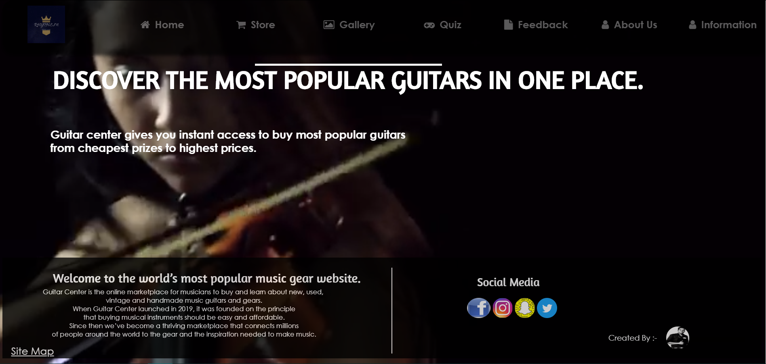

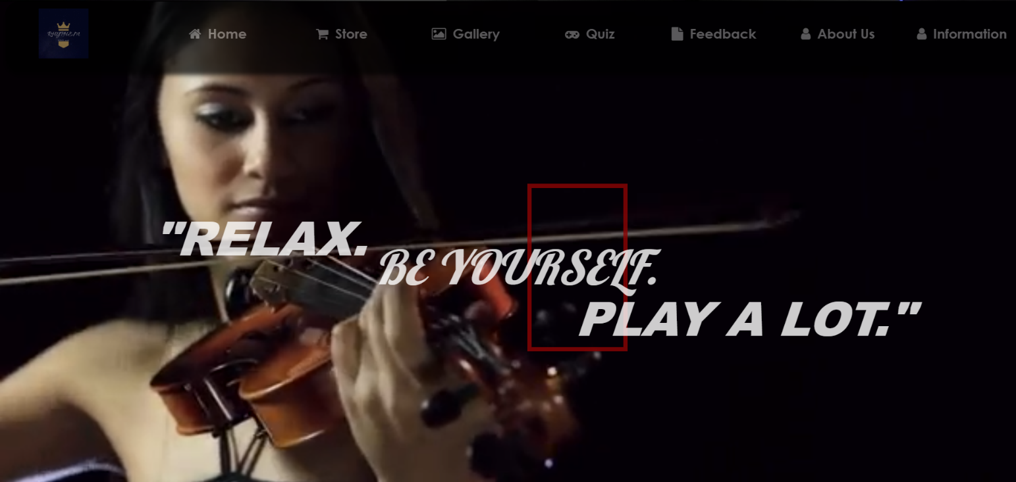

**Filename: Feedback page**

**Screenshot(s)**

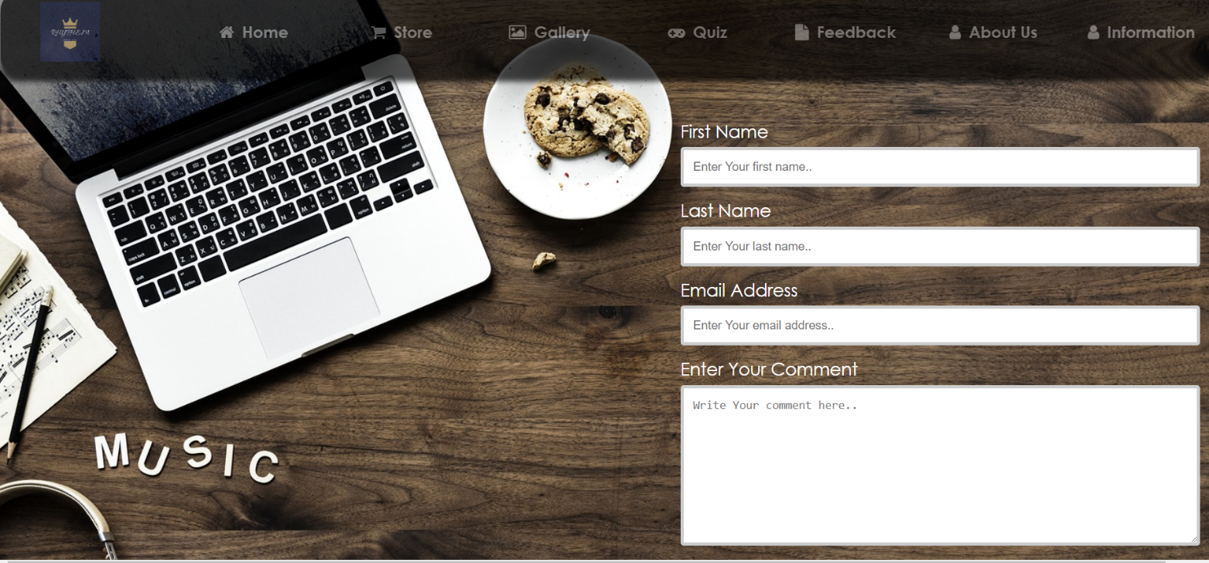

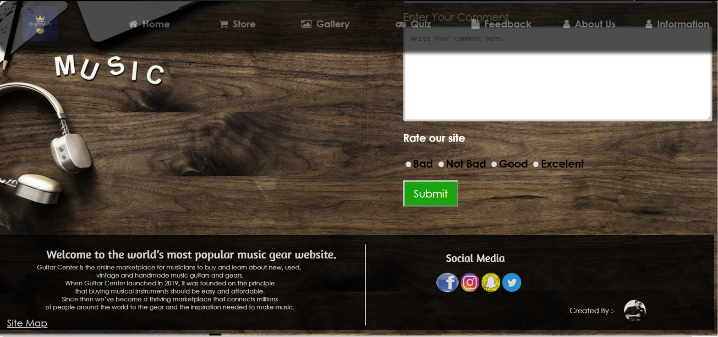

**Filename: Chamal Perera CV**

**Screenshot(s)**

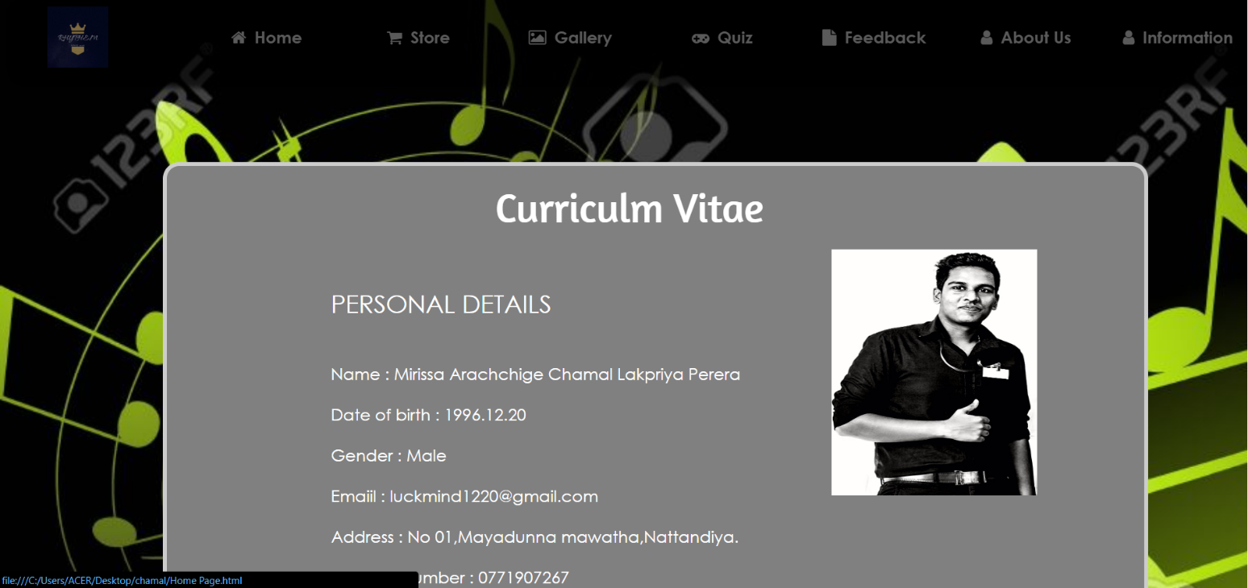

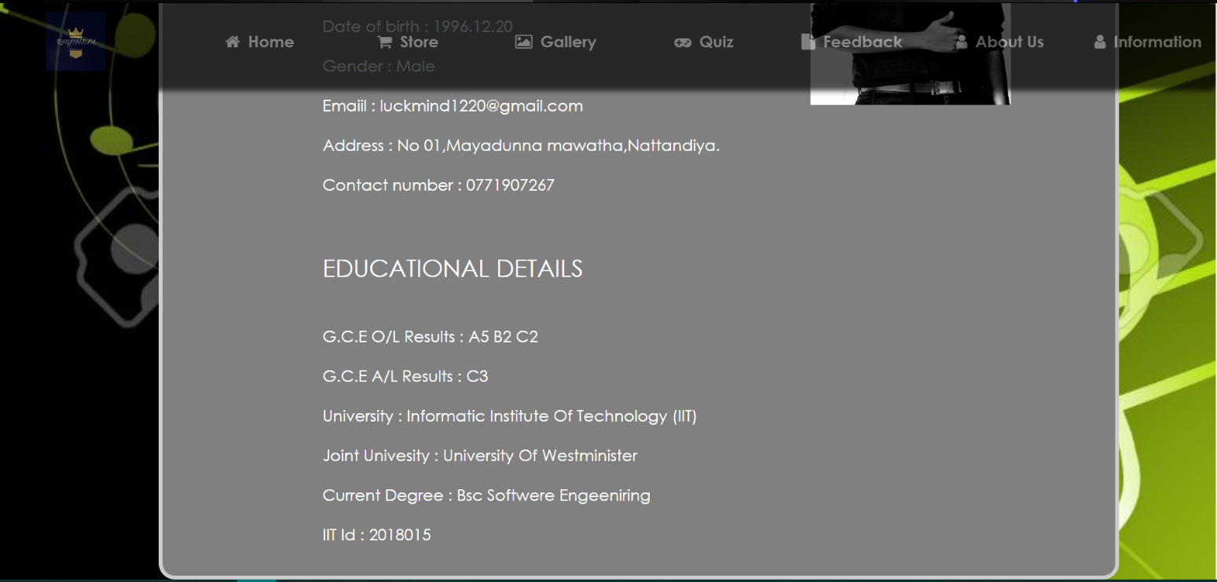

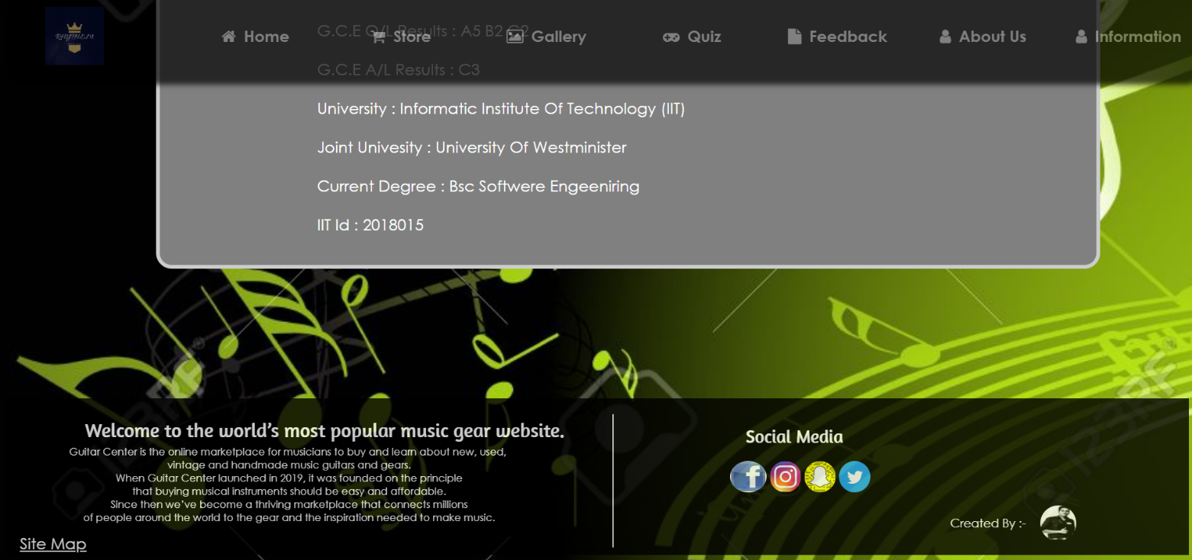

**Filename: Part B (box guitars)**

**Screenshot(s)**

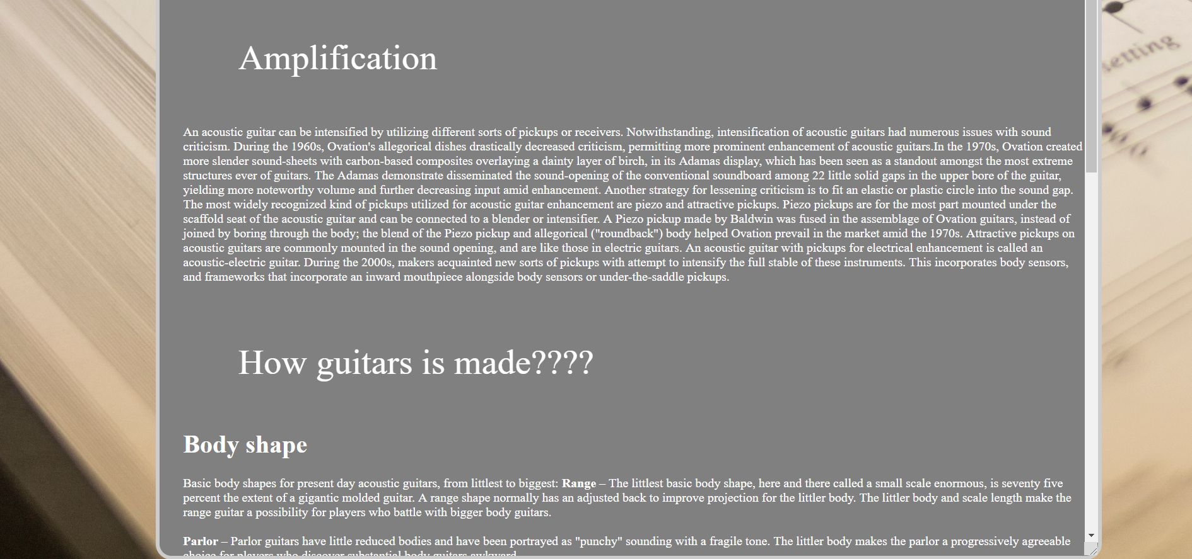

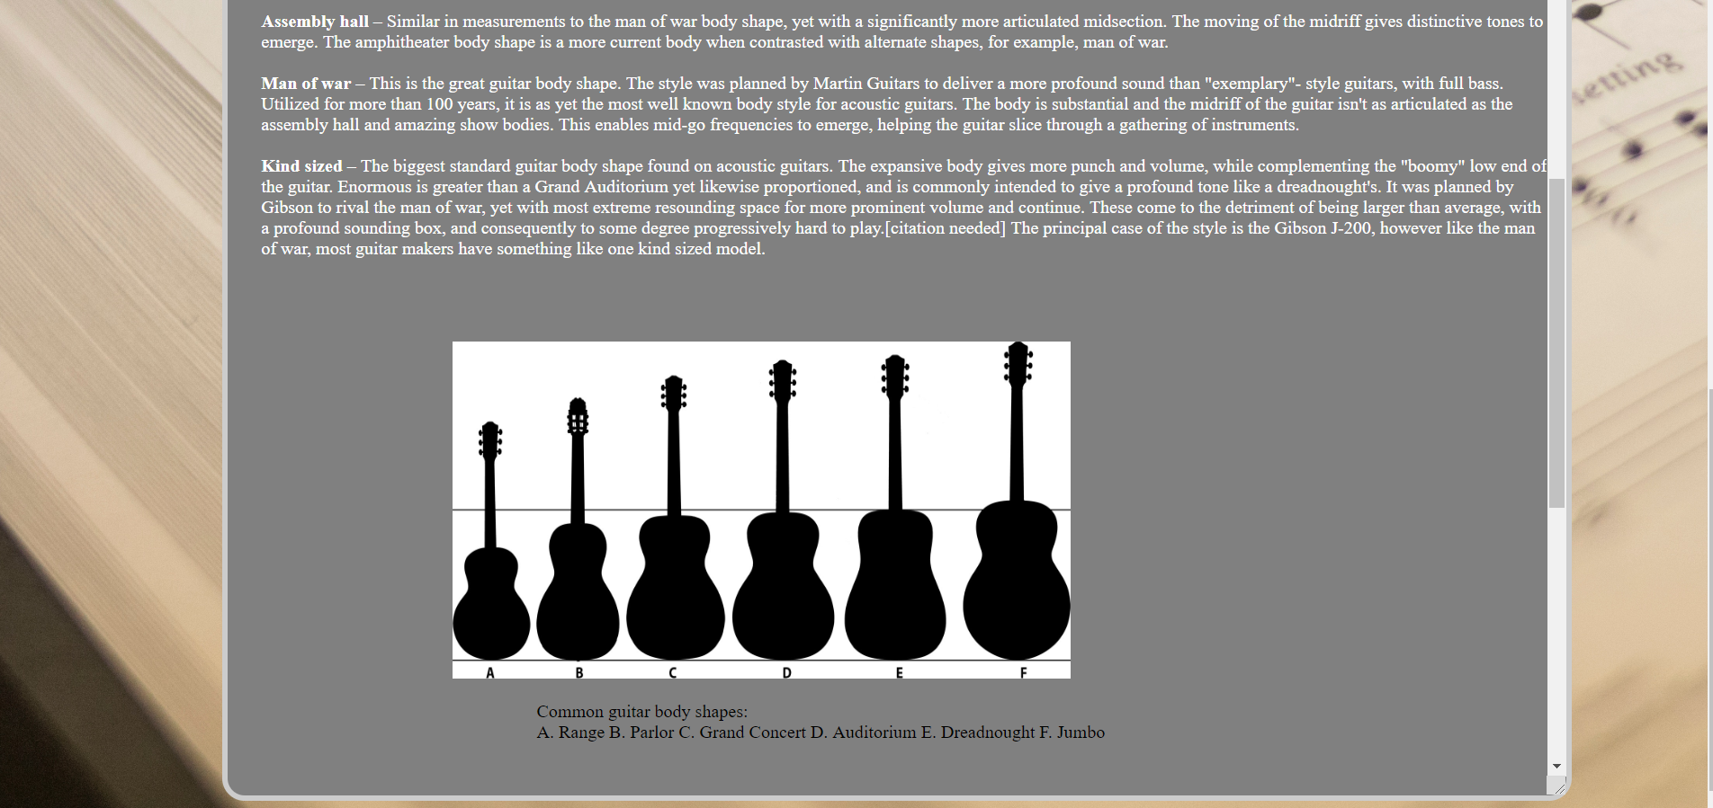

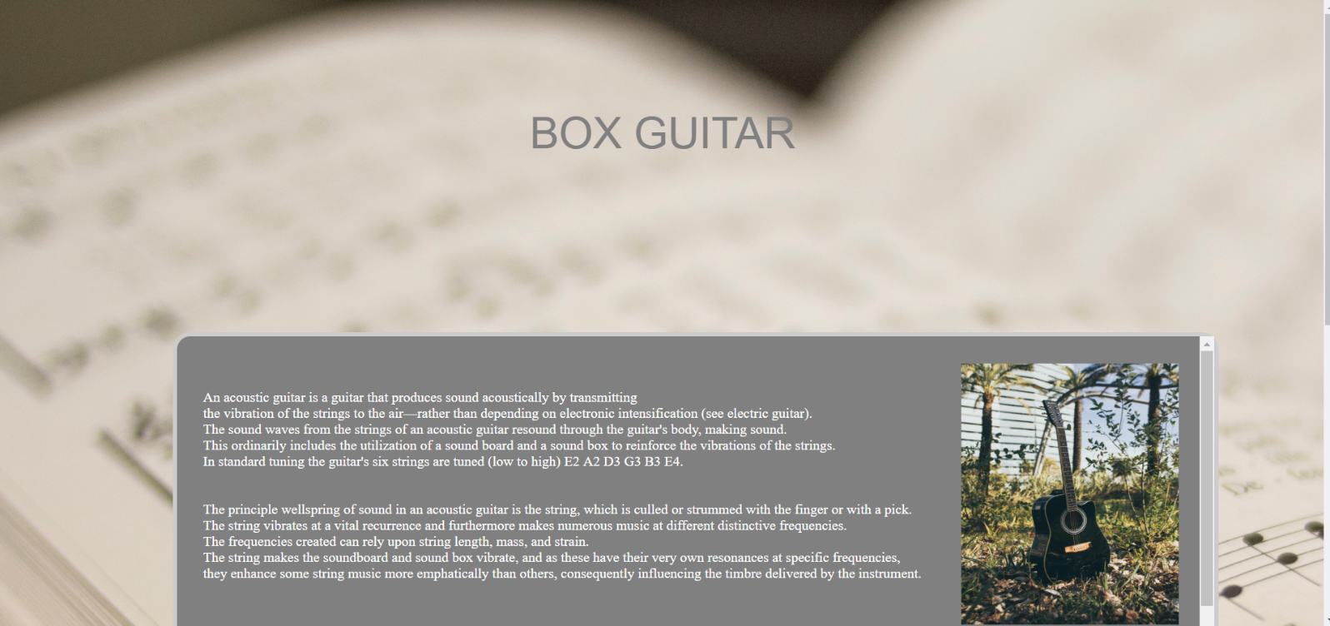

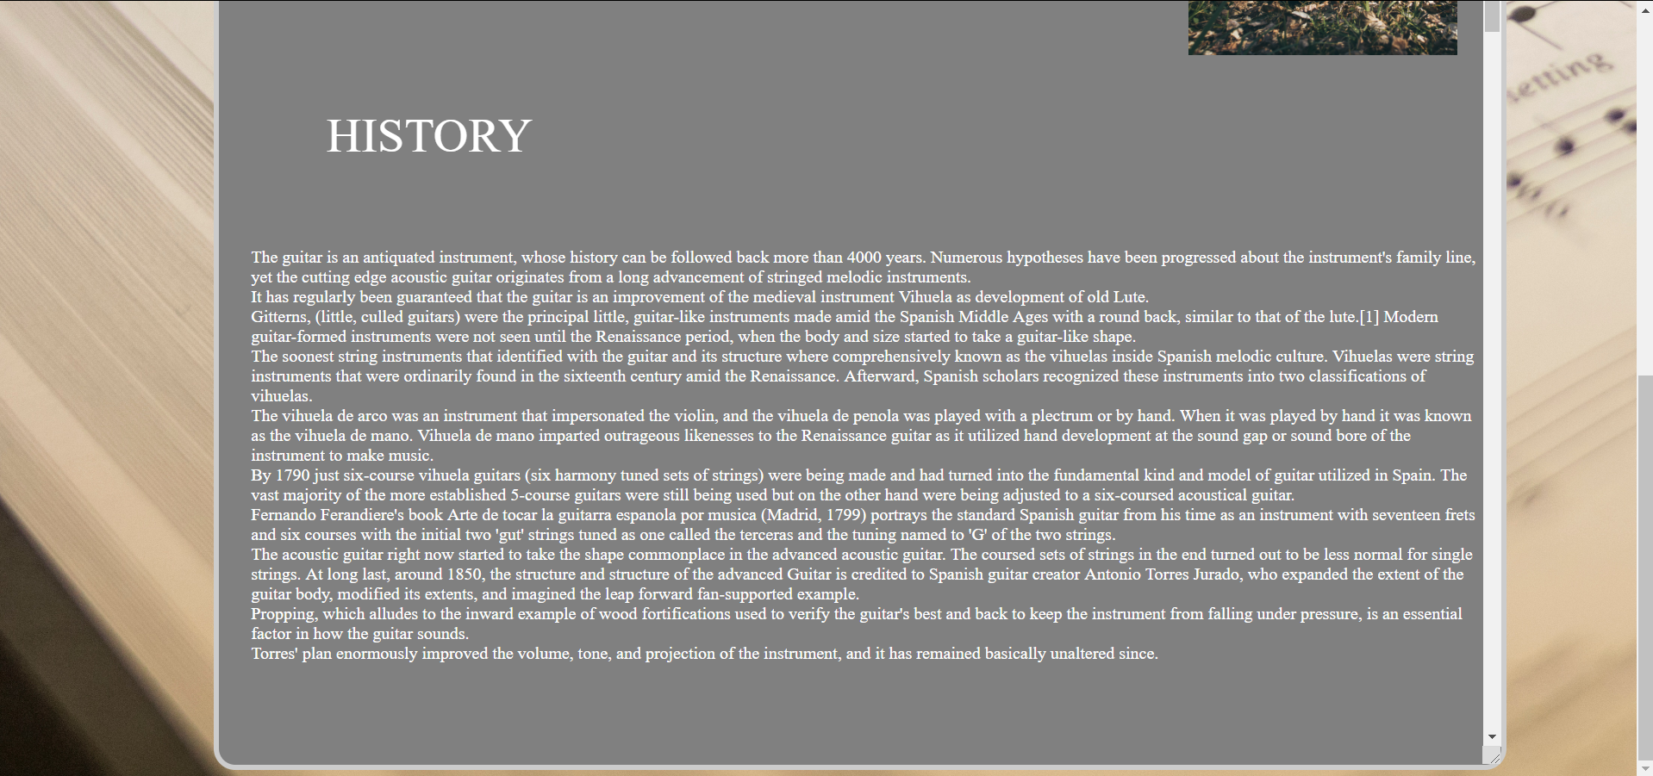

## Appendix C: Individual Statement

|  |  |  |  |
| --- | --- | --- | --- |
| Student Name: | Chamal Perera | Student Id: | W1714852 |
| State what tasks you carried out in the project. | | | |
| Home page, comment page, Chamal Perera CV, Information page | | | |
| State what you enjoyed and did not enjoy about teamwork. | | | |
| I have enjoyed Every page | | | |
| State what you learnt about teamwork. | | | |
| How to use html, CSS and java script. And team management, team work | | | |
| State what skills you gained/learnt from undertaking the project. | | | |
| Team coordinating.  Team work.  Html coding. | | | |
| State any strengths about yourself that emerged whilst undertaking the project. | | | |
| Pation, leadership, coordinating skill | | | |
|  | | | |
| State any weaknesses about yourself that emerged whilst undertaking the project. | | | |
| Fear about the course work whight. | | | |
| State how you would do things better if you were to undertake the project again. | | | |
| With good coordinating and with good team work | | | |
| Additional general or project specific comments: | | | |
| no | | | |
| Student  Signature: |  | Date: |  |